2011
Sara Deen
Agricultural Science 411
1/1/2011
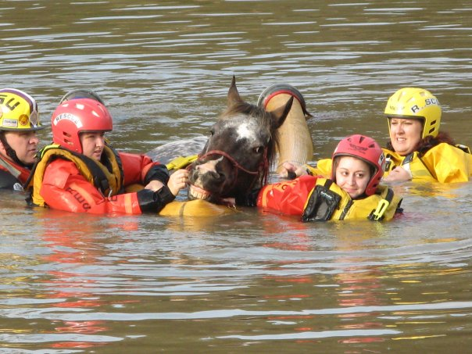
Large Animal Rescue

Abstract

Large Animal Rescue

By: Sara Deen
January 2011

Large animals can have a value to their owners as an investment, income, or sentimental value. Thus, an owner may put themselves at risk trying to rescue their animal, and it is because of this that specialized methods, equipment, and training has been developed to protect both the owner and animal. Large animal rescue is nothing new, today however, techniques and equipment have evolved to make rescuing large animals safer not only for the animal, but for the responders as well. This paper discusses the importance for large animal rescue, and reviews some techniques that are used in different scenarios. The future of large animal rescue and the current programs in Louisiana are reviewed as well.

KEYWORDS: Large Animal Rescue, Technical Large Animal Rescue, Emergency Animal Rescue, Large animal rescue in Louisiana

Table of Contents

Abstract ii
Introduction 1
Overview 2
Importance 4
Special Techniques 7
Future 13
Conclusion 14
References 15
Appendix A: Interview with Dr. Rebecca Gimenez 16
Appendix B: Interview with Dr. Renee Poirrier 17

List of Illustrations

List of Figures
Cover Page: Swimming Horse i
Figure 1: Livestock in Disasters 5
Figure 2: Sideways Drag 7
Figure 3: A-Frame 8
Figure 4: Horse on Glide 9
Figure 5: Swimming Horse 10
Figure 6: Catching Horses 10
Figure 7: Horse in Mud 11

Introduction
Many people own large animals such as horses and cattle, which are valuable as an investment, income, or have sentimental value. It is because of these reasons that owners will put themselves in danger to rescue one of their large animals in need. To protect these owners and the animals they wish to rescue, special trainings have been developed with methods and equipment to assist in these particularly challenging rescues. Large animal rescue is nothing new. Before the invention of the combustion engine, horses, oxen and other beast of burden were one man’s main mode of transportation and work. Because of this, these animals were very valuable for livelihood and were taken care of. An example of this is that back in 1867, Massachusetts had the first equine ambulance equipped with a crude sling for patients.

Today the role of these large animals, especially horses, has moved from that of which it used to be. Cattle still play the same role as a food source as they once did, but the role of horses has been replaced by motorized vehicles and American culture now puts the horse into a more companion animal role. Because of this, developments in large animals rescue and techniques slowed. An example of this would be the closing of Harvard University’s veterinary hospital. Horses made up the majority of its patients, but “with the assumption that horses would no longer be necessary as cars became more available and affordable, the hospital closed in 1904” (Gimenez 4). Just like before though, these animals can find themselves in incidents which require human assistance for rescue. However, today better methods have been developed to free these animals from predicaments by assisting, shifting or lifting the animal without causing further harm to the victim, and with less risk to rescue personnel (although all rescues are dangerous).

In past years, if an owner found their horse in need of rescue, such as being stuck in the mud, they would call friends and neighbors for assistance to free the animal, as is sometimes the case today. Tractors, winches, and ropes were often the equipment of choice for this rescue, but without proper training, the horse and sometimes rescuers, were injured and even killed as a result of the rescue. Today many owners call 911 and expect their tax paid and volunteer first responders to be able to rescue the animal safely. Unfortunately in an informal survey of law and fire service personnel by the authors of Technical Large Animal Emergency Rescue, it was discovered that only about 5% of first responders knew something about handling large animals and even fewer than that felt comfortable about handling a large animal (Gimenez XI). This shows a need in more training to safely rescue large animals. Today, there are several organizations and schools that offer this specialized training.

Overview

Rescue:
The word ‘rescue’ must be defined for this papers purpose. One type of rescue, which many people think of in terms to animals, is taking the animal out of situations that involve neglect, abuse, or cruelty (Appleby). The first act that allowed for the persecution of farm animal cruelty was in the United Kingdom, and is known as Richard Martin’s Act which passed on July 22, 1822 (Gimenez 3). Richard Martin brought a donkey into the court room to show how a farmer had beaten the animal. Although this shows the concern and care society has towards its animals, this paper focuses on a different type of rescue.

The rescue that this paper focuses on an animal being entrapped (mud), recumbent and unable to get up, caught in a confined space (such as a collapsed barn), fallen into a trench, ravine, or water, entangled in fencing or panels, loose from confinement, and vehicle accidents (trailer tips, collision with vehicle). Any of the previous accidents by itself is considered an incident. A number of incidents may occur in a short amount of time and overwhelm rescue personnel, such as after a hurricane, and these combined incidents are considered a disaster (Gimenez 19).

Unfortunately, there is no centralized database of animal rescues for statistics or even records. Even traffic accidents which are kept recorded by police do not include whether or not animals are involved (Gimenez 16). Dr. Gimenez, along with others, have compiled stacks of articles along with recorded personal accounts that can attest for the number on incidents. Although police officers and firemen have extensive training, SOPs (Standard Operating Protocols) that are used as a guide with many rescue situations rarely include large animals (Gimenez 12). Because of this, several organizations and schools are now offering specialized training on how to handle and rescue large animals along with compiling stories of large animal rescues.

Animals and American Culture:
Why waste time and money saving one animal life? Will one animal really make that big of an impact on a person’s income, investment, or life (from sentimental value)? Well, some animals have gained a high status in the United States, and many animal owners consider their pets as another family member. The horse is an example of this for large animals, and it is taboo to consume horse meat in the United States. From natural disasters, such as hurricanes, is has been seen that pet owners are often reluctant to evacuate without their animal companions. A famous example of this would be during Hurricane Katrina when many owners would not leave their pet to evacuate early or were forced to be separated from their pets at shelters that did not offer pet accommodations. In the aftermath of Hurricane Katrina, the PETS Act (Pets Evacuation and Transportation Standards Act) was passed in 2006 by President George W. Bush which now requires FEMA and other emergency agencies to include pets in their emergency planning ("PETS Act prevails"). In the American Animal Hospital Association’s pet owner survey, 74% of owners said they were willing to go into debt to care for their pets and 27% have included their pets in their will (Gardyn 16). These examples show the statues of animals in American culture and are why many owners will risk their life to rescue their beloved animal. To protect well meaning animal owners, rescue personnel will use resources to rescue the animal.

Large Animals:
Although many large animals do not hold the same cultural status as other small companion animals, with maybe the exception of the horse, many people still want to see an animals in need rescued. Large animals present a bigger challenge in being rescued than the small animals. Even large dogs can often be picked up and carried be a strong man from being trapped in a well. A horse however, even a miniature horse, requires extra assistance in the form of training and equipment. Methods have been developed using to safely rescue large animals without further injuring them while keeping rescuers as safe as possible.

Importance

Psychological- Animal and Human Safety:
Animals hold such a high status in American culture, that people will often become amateur rescuers to try to help animals in need. Rescuing large animals (cattle, horses, llamas, alpacas, pigs, goats, and sheep) is more challenging than small animal rescue mainly due to the mass and volume of the animal. A cat or dog can be easily carried while the previous cannot. Amateur rescuers trying to save a cow that has fallen in a raving will often use the animals head, neck, and legs as anchor points to pull from and this often causes the animal to pull back and fight rescuers instead of helping, besides the fact that using this method could injure the animal further (Gimenez 21). Proper training makes these rescues not only more successful, but more efficient. In the UK, three counties that had training and equipment improved their animal rescue success rate from 4-10% to ~96%, see table 1(Gimenez 10)!

Untrained rescuers also often forget to assess the situation before rescue. This leads to the animal not receiving initial life-support or medical attention, which is often easier to administer while the animals is trapped than when it is out. For example, if you have a horse stuck in the mud for several hours, it will probably be dehydrated and it is much easier to start an IV while the animal is ‘stuck’ than when it is out and perhaps wanting to run from the crowd of people. The lack of planning before the rescue also often includes not planning for what to do with the animal once it is out of its predicament. Has containing the animal been thought of so that it doesn’t run back into the mud it was just rescued from or into a busy street? Has transportation been thought of to get the animal away from the area, or to a veterinarian to be treated for trauma or injuries?

Another factor is human safety. Many injuries occur each year rescuing animals. One fatality, 192 hospital stays longer than three days, and 178 serious injuries were recorded from 1999-2002 from both small and large animal rescues to police officers in the UK (Gimenez 18). Even animals that are normally gentle and calm may become frantic and unpredictable in rescue situations where a lot of stress is involved. Loud and strange equipment used in rescue can also frighten an animal and cause the animal to react unfavorably. Remember, we are predators by nature, horses are prey animals, so even a well trained horse may have that self preservation instinct to kick when there are all these “predators” around (the horse does not understand you are trying to rescue it). This can make the situation dangerous if not properly trained because less than 3,000 years of domestication has not even put a dent in 300 million or more years of evolution (Gimenez 2008). Knowledge of large animal behavior for is crucial to personal safety and knowing how the animal may protect itself by biting and kicking. An accidental kick from even a small horse can cause serious injury or death. For this reason, first responders will often rescue animals to protect the general public from becoming involved. Gimenze recounts a 2004 rescue of two Canadian geese that were trapped in a frozen lake in which “saving geese or other animals is not a priority of the fire department, but saving human life is”(Gimenez 22). An ice rescue team was dispatched to save the geese to prevent bystanders from trying to rescue the animals and possibly ending up needing rescuing themselves.

Ethics:
Animals are considered property and it is the owner’s responsibility to care for their animals. Neglect is often thought of when animal control officials must confiscate an animal from its owner due to lack of proper care. In the public eye, neglect can also be not aiding an animal in need of rescue. This leads to amateur rescuers and once again, first responders stepping in to keep the public safe and figure 1 shows just how linked humans are to livestock in incidents or disasters. Many people think that rescuing the animal regardless of value is just the right thing to do. If a situation is deemed too dangerous on human life, then the animal will not be rescued. However, no one wants to see an animal in distress and suffering.

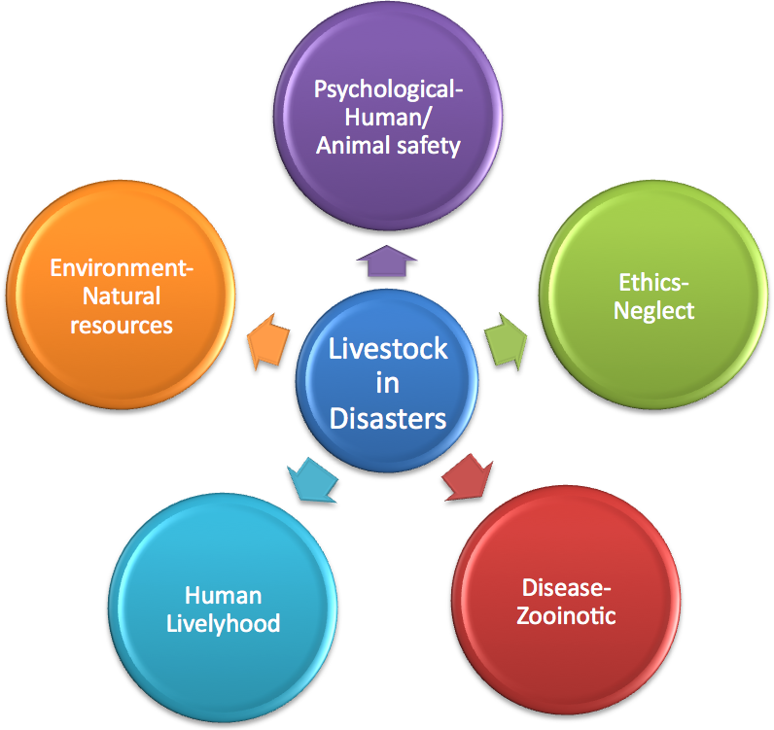

Fig.1 Livestock in Disasters. Model of affects of livestock in disasters

Disease:
Protecting or saving an animal can also help with disease control. For example, a farmer probably doesn’t want to leave a dead animal in a pond or creek where other animals drink, or even to decay around other animals where is can become a host to bacteria and parasites. The cost of removing the carcass may be worth rescuing the animal. This may also protect humans from certain zooinotic diseases by preventing their spread.

Human Livelihood:
Many large animals are very important for food and trade, and this is how some people make a living. Other animals may be an investment for show or breeding stock. Disasters will have the most impact on this- hurricanes, floods, tornadoes, severe winter, drought, wildfires, disease outbreaks, and earthquakes are natural disasters that can destroy farms and ranches. Man-made disasters such as oil/chemical spills can also lead to disasters if they contaminate animal food and water. Although saving individual animals doesn’t seem to make that much of an impact on farms, replacing these animals can add up quickly, especially if they are high quality animals.

Environment:
Protecting the environment is very important, especially if someone is trying to raise livestock on a piece of land. Rescuing animals can keep food and water sources safe from decaying carcasses. It may be worth rescuing an animal rather than putting it down only to have to recover the carcass and replace the animal. This will keep the herd safe in the long run. Even catching loose animals can save fencing.

Special Techniques
Equipment:
In many areas, first responders and even animal care specialist do not have specialized ‘large animal’ rescue equipment. For some procedures, such as a nikopoulos needle in a mud rescue, specialized equipment may not only make the rescue more efficient, but may be necessary. However, techniques for rescuing large animals using equipment that first responders, such as fire fighters, have with them have been developed. Some of these include webbing for drags, glides, and training for build A-frames for vertical lifts.

Procedures:
No rescue is exactly alike and it takes training and planning to decide the best way to rescue an animal, basic scene assessment. This section has a few examples of techniques that may be applied to rescue a large animal and some of the equipment needed (in an extremely simplified form).

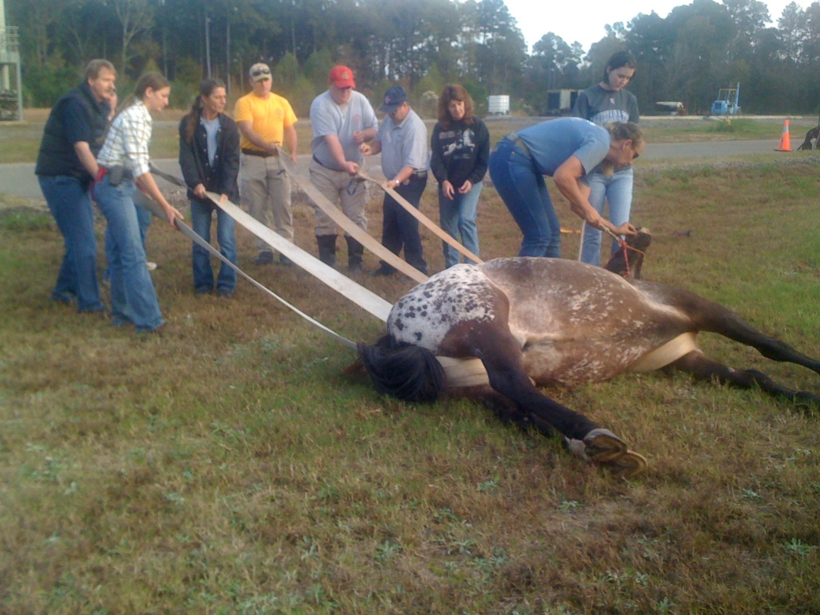Forward Assist/Backwards Drag and Sideways Drag- This procedure can move a recumbent animal out of a dangerous spot. Webbing with a minimum width of 4” is required to prevent internal damage to the animal and it is recommended that it be rated for a weight higher than the animal is estimated to weigh. It takes manipulation to run the webbing under the animal and training to know how to place the webbing. For the forward assist, the webbing is under the animal’s torso with the end coming out under the belly going over the front legs and the other end crossing on top of the neck. For the backwards drag, the webbing is done the in a similar fashion. For the sideways drag, see figure 2, the webbing is first run under the animals torso but then the crossed between the legs of the animal to prevent the animal from “rolling due to ground traction” (Gimenez 245). This exercise takes man power to drag the animal.

Fig.2 Sideways Drag. This is a demonstration of a sideways drag. Note the placement of the webbing to prevent the animal from rolling.

Vertical Lift- This procedure is used to lift the animal upwards. An example of using this would be cases of animals falling in holes. Three methods for the vertical lift are the use of a helicopter, heavy equipment with a boom, and an A-frame. A helicopter is usually not practical and is an expensive technique. Heavy equipment with a boom (arm that moves upward) may also be used but may scare the animal or it may be unable to get close enough to the site due to location. The A-frame is a simpler way to perform a vertical lift and fire fighters are trained and have the equipment to set one up, see figure 3. Someone trained in large animal rescue should help to oversee the A-frame technique to let first responders know an estimated weight of the animal, where to place webbing, and for basic large animal handling. Webbing must not be placed too far back in the front or too far forward in the back to prevent internal injury. A chest strap should also be used as the majority of a large animals weight is on the front end, thus this will prevent the animal from sliding out and falling.

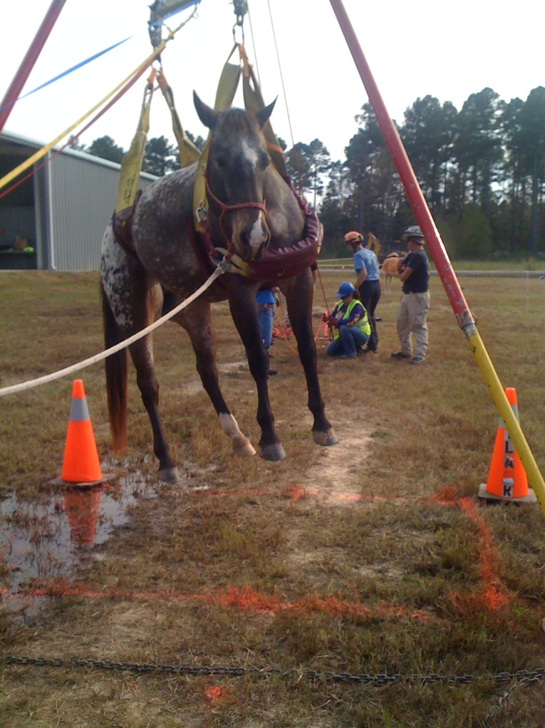
Fig. 3 A-Frame. Vertical lift with A-frame

Use of Glides- Sometimes an animal may be down and unable to get up, but needs to be moved out of the area. In this case a drag would not only be hard on pullers, but the animal may be injured by the grounds surface. To make this easier, glides (large human glides made for obese people) can be used to get the animal off the ground and allow for easier pulling with the glides smooth surface contacting the grounds surface. The animals must be secured safely onto the glide to prevent it from rolling off, or moving and possibly injuring itself or a rescuer. Anatomy of the horse must also be understood to manipulate the animal’s limbs safely and get them close to the body, see figure 4 for an example of this.

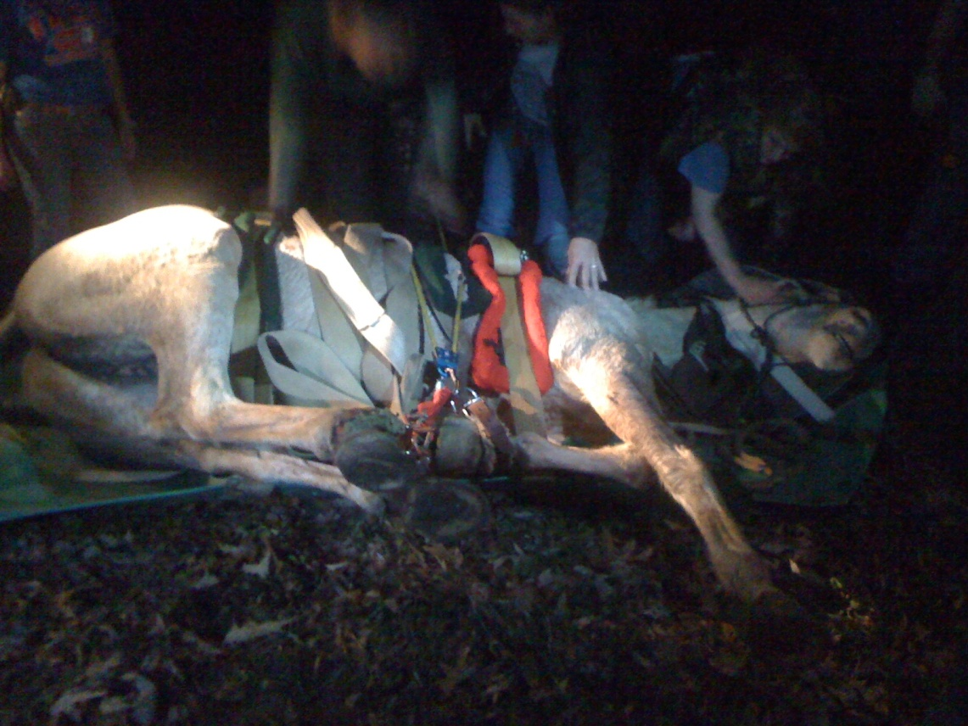
Fig.4 Horse on Glide. Training on how to secure a horse on a glide for transport.

Swimming a Horse- In some situations, swimming a horse may be a good way to move it from one place to another (Ex. horse stranded on an island in a flood). There are several ways to swim a horse. Horses can swim and guiding a horse by boat for short distances may be practical, however, the danger from the horse being injured by a boats motor, the boat going over the animals submerged back while swimming and possibly forcing the animals head underwater, and even a horse panicking and trying to get in a low sided boat causes great dangers to the animal and rescuer. Getting in the water to assist the animal is also risky and only strong swimmers should assist in this type of rescue as horses can swim fast and can still kick under water (or accidently hit a rescuer with its legs while swimming). Rescuers should always wear PFDs (Personal Flotation Devices-lifejackets) and helmets during this type of rescue. For the training that I attended for this type of rescue, a surcingle was put on a horse to attach a floating device to aid the horse and protect human swimmers. A piece of a fire hose was inflated with air (this is a developed piece of equipment) and bent in a V shape to act as this floatation device. The hose was then placed around the animal in the water with the head towards the closed end of the V for the horse to rest its head and to keep the animal from swimming out of it. Straps with clips on the hose were also attached to rings on the surcingle. A team of people were used to guide the swimming horse and keep its head above water see figure 5.

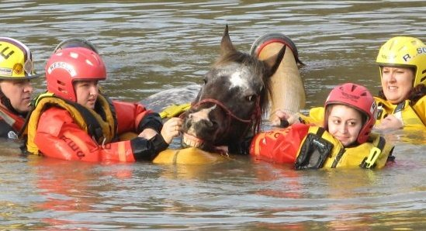
Fig.5 Swimming Horse. Training on swimming a horse. Source: Photo courtesy of Dr. Rebecca McConnico.

Loose Large Animals- Not only must an animal be contained after rescue to prevent it from running back into the area it was rescued from, but large animals also often get loose. Owners are responsible for their loose animals and any damage they may cause. Neighbors are often called to help round up loose animals but sometimes first responders are faced with this task (an example would be trailer accidents). Portable fencing can be made out of many things, but one of the best things I’ve seen used is the plastic barricade netting, see figure 6. This is light, can be easily rolled up for storage and transport, and is easily visible (more so than roping). People or light ground poles can be used to hold it. Knowledge of large animal behavior is very useful if catching and containing these animals.

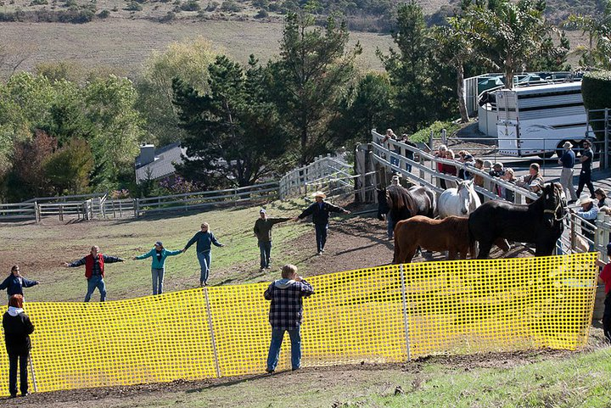
Fig.6 Catching Horses. Using plastic netting to contain horses. Source: Picture courtesy of Dr. Rebecca Gimenez

Mud Rescue- There are many stories of large animals being entrapped in mud from floods, landslides, or from going into areas where they shouldn’t of. Special care should be taken in this rescue to prevent further injury and get the animal out quickly. If the animal is unable to move forward, a vertical lift is necessary. As discussed earlier, this can be done with the use heavy equipment or an A-frame. There are challenges of getting the webbing underneath the animal if the torso is too deep in the mud. The nikopoulos needle is a specialized piece of large animal rescue equipment to meet this need. The nikopolous needle is in the shape of a wide C and is about 6 feet long by 4 cm. There are pin holes all along the barrel, and an opening on one end with a loop to attach a pilot line. On the other end is a fixture to screw on a hose. A hose is attached to it, and air or water pressure from a fire truck or an air-manifold with a minimum of 30psi is used to allow for the needle and pilot line to go through the mud easier, see figure 7. Once the two strips of webbing and a front guard are around the horse, it can be attached to the lift. But, there is still the issue of breaking the pressure of the mud must be addressed. Without this vacuum being broken from the mud, the animal being lifted may be further injured. The suction of the mud can create a vacuum that is three to four times the animals weight (Gimenez 2008). Webbing may be broken, or the animal may be injured or even killed if this vacuum is not broken (hooves have actually been sucked off of horses). So to break this suction, mud lances, which are four feet long and one inch, that have pin holes through out, with one end open and one end with an attachment for hoses, like the nikopolous needle, are placed in quarters, or around each limb, of the animal and use air or water pressure from the same source as the nikopolous needle (keep in mind that if the animal is in a pit, you may not want to opt for water pressure to break the vacuum since the hole may fill quickly and drown the animal). This allows for the suction to be broken and the animal can be lifted safely.

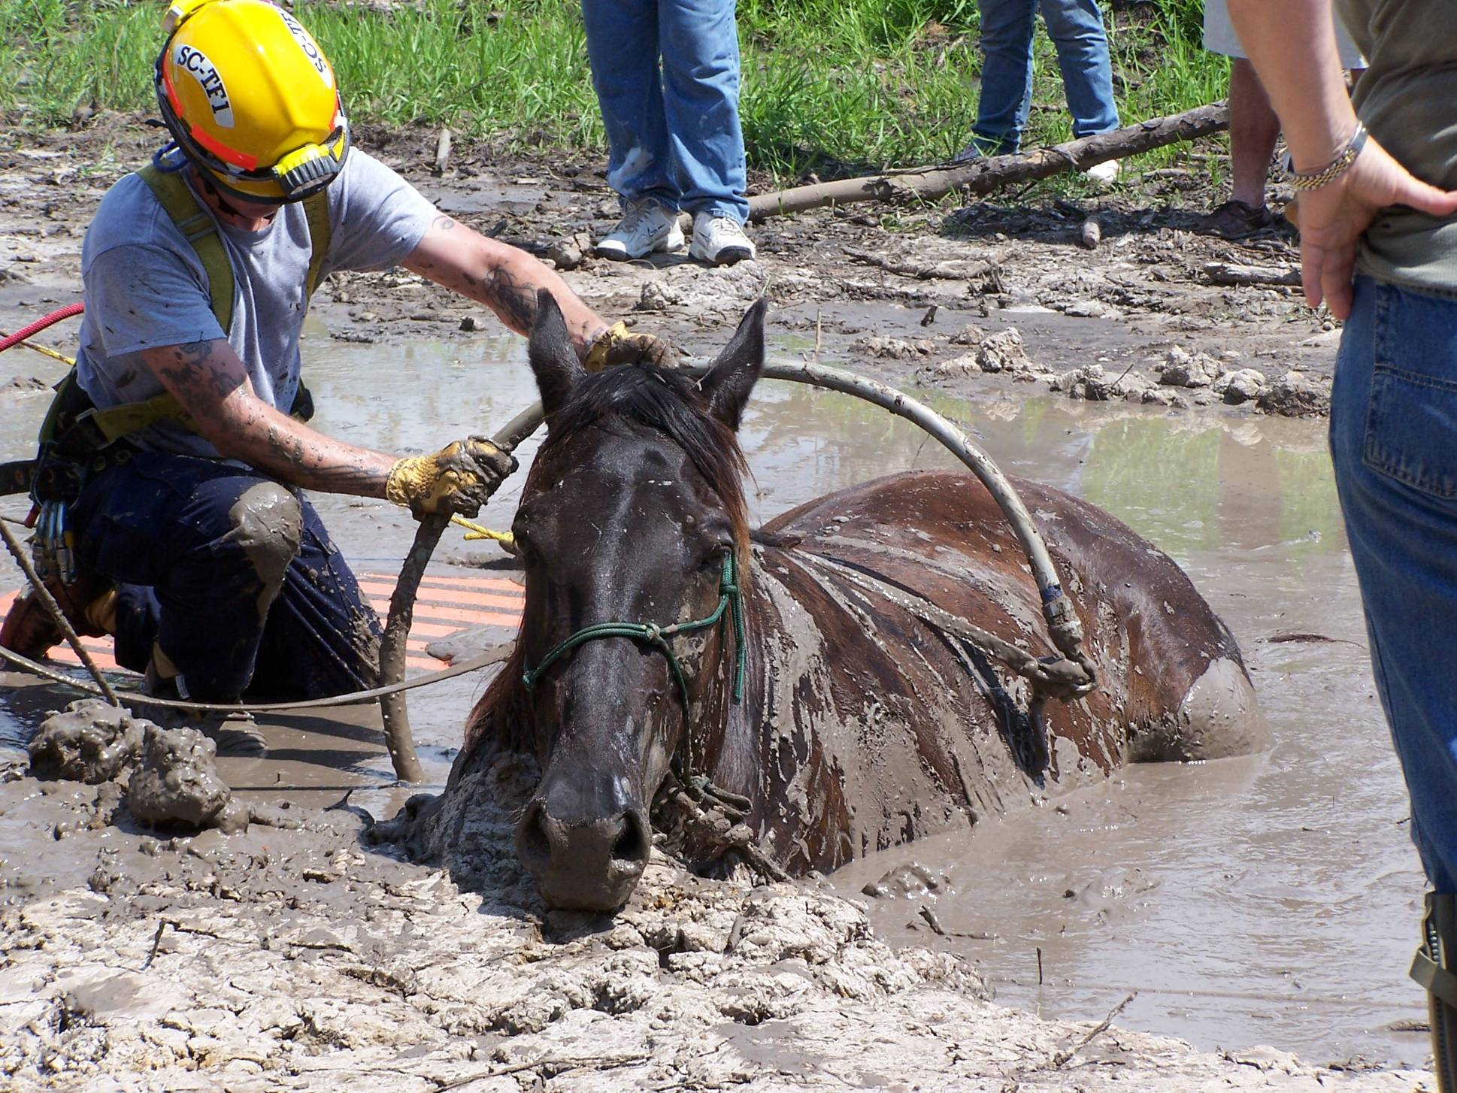
Fig.7 Horse in Mud. Picture shows the use of the nikopoulos needle. Source: Picture courtesy of Dr. Rebecca Gimenez.

Better Rescues:
Improper rescues can prolong the time the animal is in the predicament, cause secondary injuries or death, and compromise the medical status of the animal (Gimenez 345). By 2006, six veterinary schools in the United States offered some type of large animal rescue training (Gimenez XII). In the UK, statistics have shown that before the TLAER program, 90% of the injuries an animal had were a result of the rescue and not the actual incident (Gimenez 2009). This just goes to show how important this training is (so don’t try this at home).

Other Uses of Techniques:
The techniques and methods developed in large animal rescue can also be applied in everyday use. Animal hospitals can apply the techniques to move animals safely with minimal stress. These techniques can also be used outside of rescue and health care, such as in zoos to move animals to different enclosures (www.TLAER.org).

Future of Large Animal Rescue

Nation Wide:
There are now many organizations and professional schools offering forms of large animal rescue. Eastern Kentucky University was one of the first schools to pioneer an ‘ani-medic’ program in the United States. This was meant to teach first responders some of the basics of animal emergency care and things to check for until a veterinarian should arrive. US Rider has sponsored TLAER courses for students there for years. However, the ‘ani-medic’ program has currently stalled due to limited faculty, although they hope to restore it in the future. Arizona currently has an emergency vet assistance course similar to what EKU had (Miller). According to Dr. Gimenez, as of 2006 six veterinary schools now offer large animal rescue training (Gimenez xii). In 2009, the American Association of Equine Practitioners formed their Equine Emergency Task Force after several devastating hurricanes (Gimenez 9).

In Louisiana:
Many states have a SART (State Animal Response Team). In Louisiana, this team is known as LSART (Louisiana State Animal Response Team). LSART began as a committee of the Louisiana Veterinary Medical Association and later moved to a foundation so as to gain non-profit status (Poirrier). LSART has been involved in many disaster relief efforts, which include all sizes of animals, for multiple hurricanes, a flood, and with the Deep South Horizon Oil Spill. The organization runs off grants and could be called to help in individual large animal rescues, but so far has not been. Many times people will call Dr. Rebecca McConnico, who is the director of the equine branch for LSART (Poirrier). Dr. Renee Poirrier believes that training to rescue large animals is crucial for safety of the animal as well as people, and LSART will continue to train people and let first responders know they have an option for assistance (Poirrier). At LSU (Louisiana State University), Dr. Rebecca McConnico along with a team of others started an experimental learning in disaster response for veterinary students (McConnico). According to Dr. McConnico, “it has become a societal expectation for veterinarians to take a leadership role during times of disaster to assist animal owners and animal-care providers during a crisis”, but currently “training for certification in technical aspects of disaster response, disaster planning, and debriefing for veterinarians are not readily available” (McConnico). To fill this gap, LSART and LSU have partnered to help in many disaster situations, and have “developed a response program that includes animal response planning, evacuation, sheltering, emergency triage, and technical rescue expertise”. This program will be not only be for veterinary students but can also be a part of continuing education courses and will cover introductory levels, awareness levels, and fifty hours of hands on learning (McConnico).

Conclusion
Large animal owners value their animals in different ways as either an investment, for livelihood, sentimental value, or a combination. Owners are willing to put themselves in danger because of these reasons to rescue their animals. First responders try to protect the public by rescuing these animals and the challenges of rescuing a large animal have been recognized. Techniques and special equipment have been developed to rescue large animals more efficiently and safely. Rescuing large animals also plays a role in protecting the environment and preventing the spread of diseases or parasites. Several organizations and schools now offer specialized training on how to use rescue equipment, work with first responders, and how to rescue large animals in a variety of situations. In Louisiana, LSART and LSU have partnered to help in disasters and a program for learning about animals in disasters and how to respond is in the works.

References

Appleby, Michael C., and Tonya Stokes. "Why Should We Care About Nonhuman Animals During Times of Crisis?." Journal of Applied Animal Welfare Science 11.2 (2008): 90-97. Academic Search Complete. EBSCO. Web. 22 Jan. 2011.

http://www.aphis.usda.gov/animal_welfare/ep/acep_useful_links.shtml. Animal Welfare- Animal Care Emergency Programs (ACEP). (2011).

Gardyn, Rebecca. "VIPs (Very Important Pets)." American Demographics 23.3 (2001): 16. Academic Search Complete. EBSCO. Web. 22 Jan. 2011.

Gimenez, Rebecca. Personal Interview. 14 December, 2009.

Gimenez, Rebecca, Thomas Gimenez, Kimberly A. May. Technical Large Animal Emergency
Rescue. Iowa: Wiley-Blackwell, 2008.

Howlett, Melinda, and Celia Turnbull. Large Animal Emergency Rescue Training. Camberwell: ISS Institute, 2009.

McConnico, Rebecca S., Wendy Wolfson, Renee A. Poirrier, and Joseph Taboada. "Experiential Learning in Disaster Response for Veterinary Students and Veterinarians." Unpublished.

Miller, Danny. Assistant Professor of Emergency Medical Care at EKU (Danny.Miller@eku.edu). Personal Interview. 24 January, 2011.

Mortensen, Ky Evan. Horses of the Storm. Lexington: Blood-Horse Publications, 2008.
"PETS Act prevails." DVM: The Newsmagazine of Veterinary Medicine 37.11 (2006): 12. Academic Search Complete. EBSCO. Web. 22 Jan. 2011.

Poirrier, Renee. Director of LSART Personal Interview. 24 January, 2011.

Wittnich, Carin, and Michael Belanger. "How Is Animal Welfare Addressed in Canada's Emergency Response Plans?." Journal of Applied Animal Welfare Science 11.2 (2008): 125-132. Academic Search Complete. EBSCO. Web. 22 Jan. 2011.

www.TLAER.org (2009)

Appendix A
Interview with Dr. Rebecca Gimenez
Technical Large Animal Emergency Rescue

How often do horses get stuck in the mud?
It is unknown as to the total numbers – I have at least 50 reported stickings of horses (and several of cattle) from newspapers and Google searches – of course you know very rarely do these things make it all the way to the newspaper. If I had to guess, I would say that at least 1 horse or large animal gets stuck in my area each year – that I hear about. That equals several thousand a year across the country. I wish I had numbers for statistics!
About how many horses die, and/or are injured from this incident?
Based on the reports that I have pulled (ref above) it is about 50: 50 success. Usually the animal is there so LONG before it is found, if it does not get immediate medical attention even before it is pulled out of the mud it may die even if you get it out. Then using proper methods to A. make it efficient / quick and B. prevent injury. There are many animals that die in the mud before anyone even finds them (ugh/_)
About how many horses die, and/or are injured from improper rescues?
Same as above – about 50: 50. Statistics in the UK showed that approximately 90% of rescues of large animals were UNSUCCESSFUL (animal died or was injured even if it lived) until they started a TLAER program in the 1990s.
What’s the biggest challenge with mud rescues?
The suction effect of the mud. It can be up to 3.5 or 4 times the weight of the animal. Overcoming this effect requires breaking the vacuum – only possible with air or water injection.
How do horses get stuck in the mud (how do most end up in this incident)?
Trying to get to water, or to the other side. Many are RIDDEN into it by their owners! They may not realize the danger posed by this insidious entrapment.
About how many mud rescues have you been involved in?
Six personally, and several over the phone as a consultant. And probably 40 with my own animals purposely placed in mud (alive) and removed (alive and uninjured). The first one was the hardest – the mare was TO HER WITHERS AND HEAD deep in mud because the owner had been digging for SIX HOURS and had effectively buried her. We had 4 people, a truck with a winch, some webbing and a piece of plywood. In 30 minutes we had her out!
Appendix B
Interview with Dr. Renee Poirrier
Director of the Louisiana State Animal Response Team

How did LSART start?
LSART began as a committee on animals in disaster of the Louisiana Veterinary Medical Association. After Katrina we were moved as a division of the Walter J Ernst Foundation the nonprofit foundation associated with the LVMA. So we could be a 501c3 nonprofit.

How is LSART funded?
We are funded by funds collected during disasters especially Katrina and Rita and grants.
Has LSART been involved in large animal rescues besides natural disasters?
We could be but at this point not that I am aware of. I guess we were involved slightly with large animal in the Lafayette train derailment. We were asked to assist by local animal control. There was a train with a caustic substance that derailed in Lafayette. The area potentially affected had one horse in a pasture. Before we could determine that the substance had not leaked we identified the substance and called Becky to get us info on what this would likely do to a horse in a pasture and found out what to look for. Local animal control went out with DEQ department of environmental quality and checked to see if we had any signs of exposure and we did not.

Can people call LSART for help with large animal incidents and do you know of any other organizations in LA that may?

Usually people actually call Becky because they know she can either help or point them in the right direction.

How does LSART work with other rescue personnel/first responders?
We worked with the LSU SVM, local OEP office the local animal control office, local equine vet, wildlife and fisheries and the levee board on the equine rescue in North La a few years ago. In this case we were asked by the local vet but we can be requested by local law enforcement or fire or agriculture. Becky identified the resources needed and who may be able to provide them. We also contacted any local agency that may have any jurisdictional authority and made sure they knew what was going on and had no concerns that were not addressed. As long as we work with the animal owners or the jurisdictional authority such as local OEP, Fire or police we are working within the established system. It all starts with who is in charge In this case it was the animal owner in charge of the animal but the levee board in charge of the flooded area and the levees, Animal control and the local sheriff had authority over large animals, the OEP office in charge of the flood emergency. LSU was in charge of its equipment and personnel.

Why do you think rescuing large animals is important (aside for ethics)?
SAFETY – Human Responder safety and animal safety. Large animals if handled incorrectly can kill someone. I firmly believe that Becky’s vision of having people knowledgeable in Technical large animal rescue will make people safer. The more local police and firemen realize that large animal rescue can be extremely dangerous the more likely they are to call on trained people and a veterinarian who can tranquilize the thousand pound traumatized animal and the less likely we are to have severe injury associated with a rescue.

What are the future goals of LSART?
Continue training people and probably more importantly let the police and fire community understand that they have an option when it comes to large animal rescue. Try to accomplish the rescue with untrained inexperienced personnel or call on experienced trained people with drugs to tranquilize the thousand pound traumatized animal.

*Becky in this interview is referring to Dr. Rebecca McConnico –Head of the large animal sector of LSART and Associate professor at LSU Veterinary School.

